Features added to Hackerhousev3 (Week 3)

Area | Features Implemented | Evidence
Cybersecurity quizzes | Replaces placeholder questions with 10 real cybersecurity questions, multiple-choice answers, hints, a custom quiz screen, Submit/Cancel controls, and more flexible answer matching. | 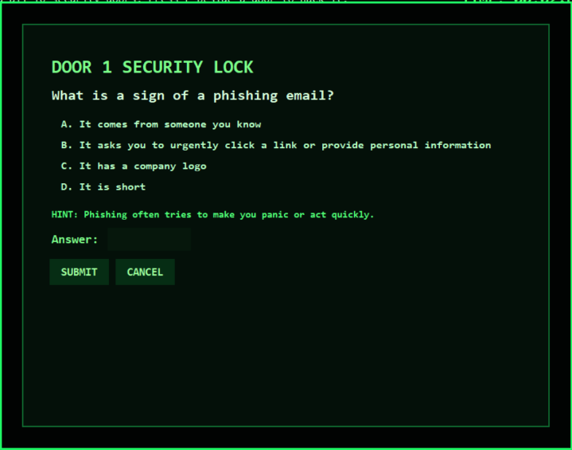
Lives and game over | Adds three lives with heart icons, damage effects for wrong answers, a final capture sequence, a dedicated game-over screen, and restart functionality. |   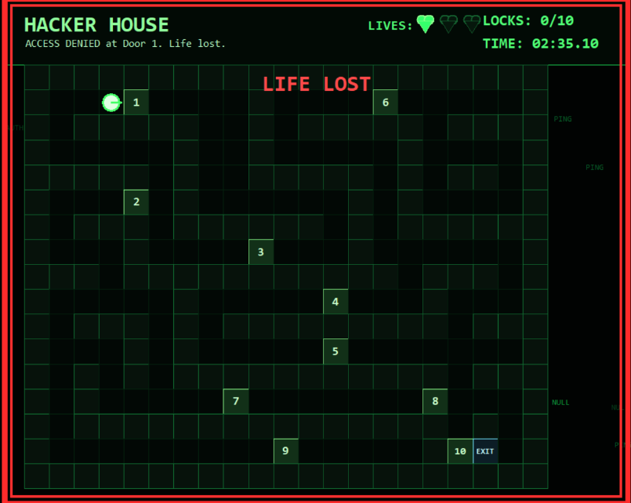  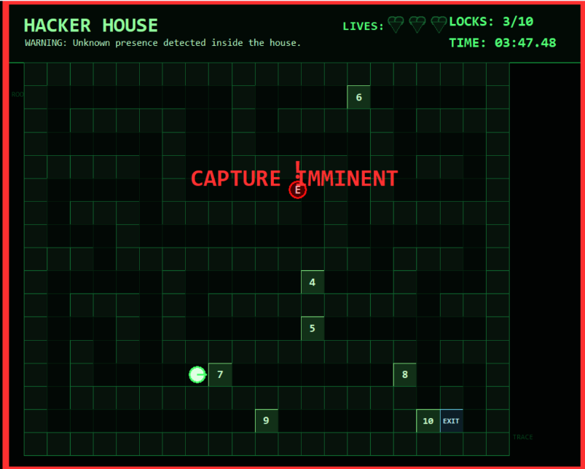  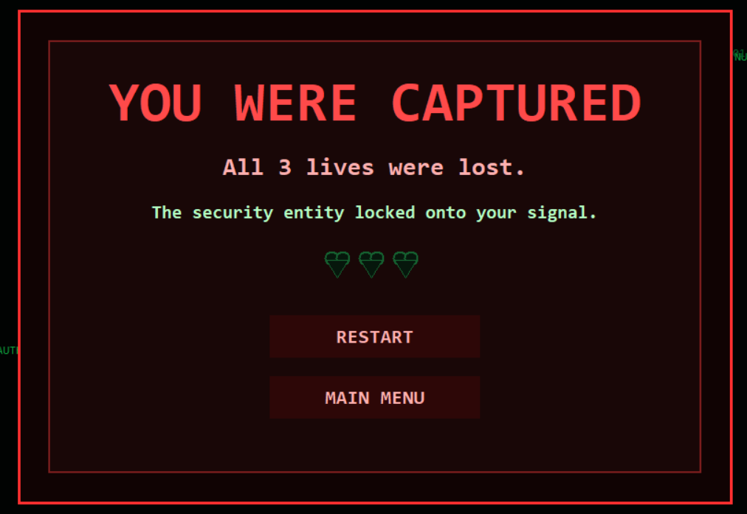
Enemy system | Introduces an enemy after five unlocked doors with pathfinding and hunt, alert, search, and capture behaviours. Unlocking doors can attract it. | 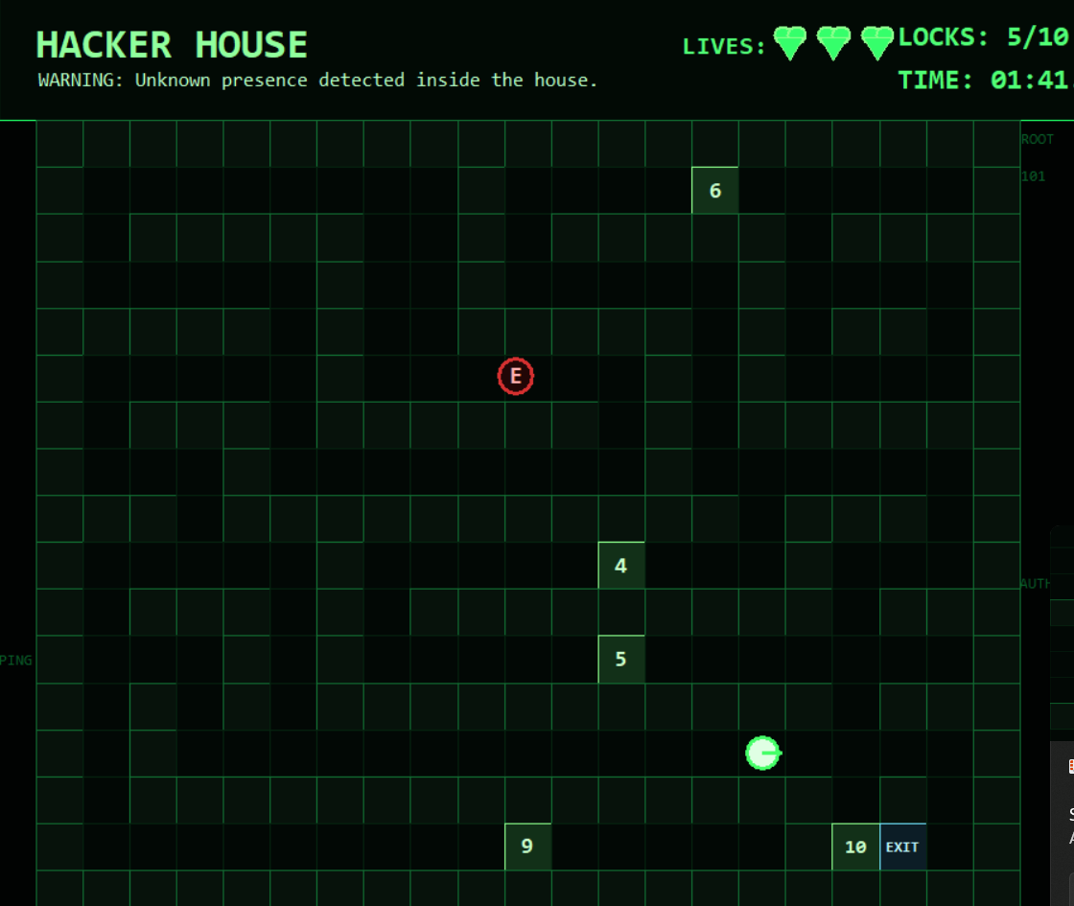
Player records | Adds player-name entry, a live timer, final completion times, a persistent top-10 leaderboard, personal-best tracking, and fastest-time previews on the menu. | 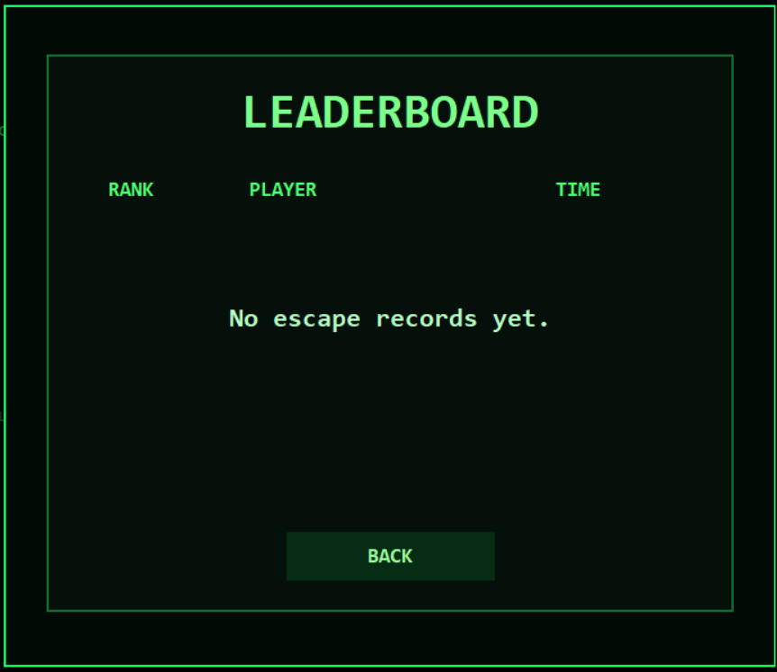    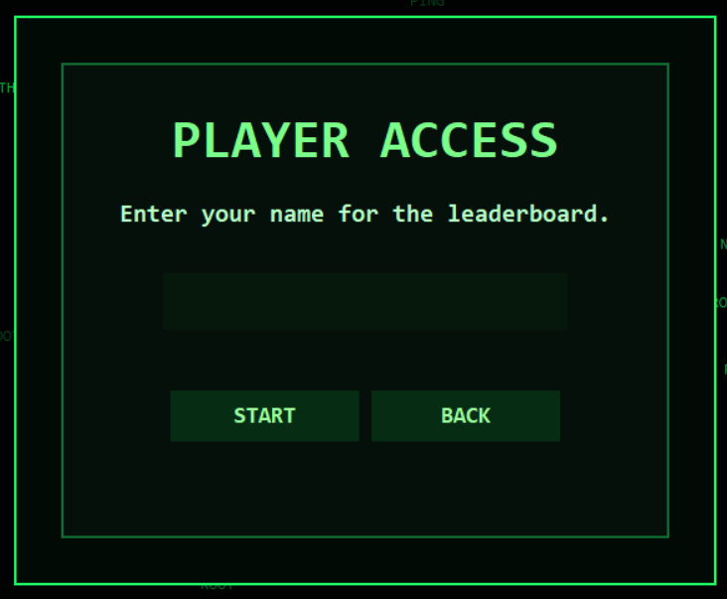
Interface and navigation | Adds a scrollable instructions screen, return-to-menu buttons, fullscreen support, window resizing, responsive UI scaling, and preservation of entered text during resizing. | 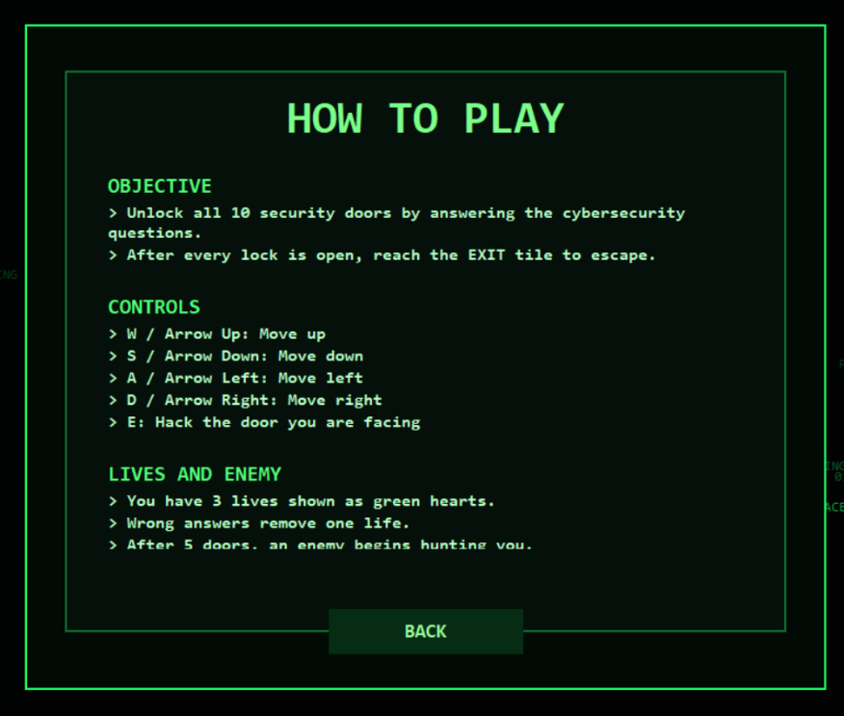
Sound and visual effects | Adds generated and cached sound effects for buttons, doors, damage, enemies, victory, and capture, plus warning loops, enemy state colours, alerts, hearts, and screen flashes.
Reliability | Adds safer boundary checks, clean game-state resets, corrupted-leaderboard handling, input restrictions during quizzes or game over, and proper sound cleanup when closing or changing screens.

